Git Repository setup
(.venv) PS D:\AIML-LAB\MLOPS_CatDog> git init
Initialized empty Git repository in D:/AIML-LAB/MLOPS_CatDog/.git/
(.venv) PS D:\AIML-LAB\MLOPS_CatDog>
(.venv) PS D:\AIML-LAB\MLOPS_CatDog> dvc init
Initialized DVC repository.

You can now commit the changes to git.

(.venv) PS D:\AIML-LAB\MLOPS_CatDog> git add .
(.venv) PS D:\AIML-LAB\MLOPS_CatDog> git config --global user.email "avimanyu400@gmail.com"
(.venv) PS D:\AIML-LAB\MLOPS_CatDog> git config --global user.name "avimanyu400"

(.venv) PS D:\AIML-LAB\MLOPS_CatDog> git commit -m "Initialize Git and DVC"
[master (root-commit) ad3b574] Initialize Git and DVC
36 files changed, 1317 insertions(+)
create mode 100644 .dockerignore
create mode 100644 .dvc/.gitignore
create mode 100644 .dvc/config
create mode 100644 .dvcignore
create mode 100644 .gitignore
create mode 100644 Dockerfile
create mode 100644 MLOPS_CatDog_Project_Documentation.docx
create mode 100644 README.md
create mode 100644 app/__init__.py
create mode 100644 app/main.py
create mode 100644 app/model.py
create mode 100644 app/schemas.py
create mode 100644 data/.gitignore
create mode 100644 data/raw.dvc
create mode 100644 deployment/deployment.yaml
create mode 100644 deployment/service.yaml
create mode 100644 dvc.lock
create mode 100644 dvc.yaml
create mode 100644 logs/cnn_model_training.log
create mode 100644 logs/logreg_model_training.log
create mode 100644 params.yaml
create mode 100644 reports/figures/cnn_confusion_matrix.png
create mode 100644 reports/figures/cnn_loss_curves.png
create mode 100644 reports/figures/logreg_confusion_matrix.png
create mode 100644 requirements.txt
create mode 100644 src/__init__.py
create mode 100644 src/data_prep.py
create mode 100644 src/payload.py
create mode 100644 src/train_cnn.py
create mode 100644 src/train_logreg.py
create mode 100644 src/utils.py
create mode 100644 tests/__init__.py
create mode 100644 tests/test_api.py
create mode 100644 tests/test_inference.py
create mode 100644 tests/test_preprocessing.py
create mode 100644 ~$OPS_CatDog_Project_Documentation.docx
(.venv) PS D:\AIML-LAB\MLOPS_CatDog>

(.venv) PS D:\AIML-LAB\MLOPS_CatDog> git status
On branch master
Untracked files:
(use "git add <file>..." to include in what will be committed)
Git Setup.docx

D:\Heart_Disease_prediction>git branch -M main

D:\Heart_Disease_prediction>git remote add origin https://github.com/Avimanyu400/Heart_Disease_Prediction_MLOPS_contaner_Deployment.git
error: remote origin already exists.

D:\Heart_Disease_prediction>git remote set-url origin https://github.com/Avimanyu400/Heart_Disease_Prediction_MLOPS_Container_Deployment.git

D:\Heart_Disease_prediction>git push -u origin main
Enumerating objects: 360, done.
Counting objects: 100% (360/360), done.
Delta compression using up to 12 threads
Compressing objects: 100% (287/287), done.
Writing objects: 100% (360/360), 2.19 MiB | 1.40 MiB/s, done.
Total 360 (delta 110), reused 0 (delta 0), pack-reused 0 (from 0)
remote: Resolving deltas: 100% (110/110), done.
To https://github.com/Avimanyu400/Heart_Disease_Prediction_MLOPS_contaner_Deployment.git
* [new branch] main -> main
branch 'main' set up to track 'origin/main'.
Upload data folder
Earlier data folder was not uploaded to git. Now I want to upload data folder also to the same repo.

D:\Heart_Disease_prediction>git add .

D:\Heart_Disease_prediction>git commit -m "uploaded data"
[main 628e716] uploaded data
4 files changed, 913 insertions(+), 2 deletions(-)
create mode 100644 data/processed_data/heart_disease_cleaned.csv
create mode 100644 data/processed_data/heart_disease_processed.csv
create mode 100644 data/raw_data/heart_disease.csv

D:\Heart_Disease_prediction>git branch -M main

D:\Heart_Disease_prediction>git remote add origin https://github.com/Avimanyu400/Heart_Disease_Prediction_MLOPS_Container_Deployment.git
error: remote origin already exists.

D:\Heart_Disease_prediction>git remote set-url origin https://github.com/Avimanyu400/Heart_Disease_Prediction_MLOPS_Container_Deployment.git

D:\Heart_Disease_prediction>git push -u origin main
Enumerating objects: 11, done.
Counting objects: 100% (11/11), done.
Delta compression using up to 12 threads
Compressing objects: 100% (8/8), done.
Writing objects: 100% (9/9), 12.81 KiB | 4.27 MiB/s, done.
Total 9 (delta 3), reused 0 (delta 0), pack-reused 0 (from 0)
remote: Resolving deltas: 100% (3/3), completed with 2 local objects.
To https://github.com/Avimanyu400/Heart_Disease_Prediction_MLOPS_contaner_Deployment.git
3fbac80..628e716 main -> main
branch 'main' set up to track 'origin/main'.

Now my data folder also copied to git.
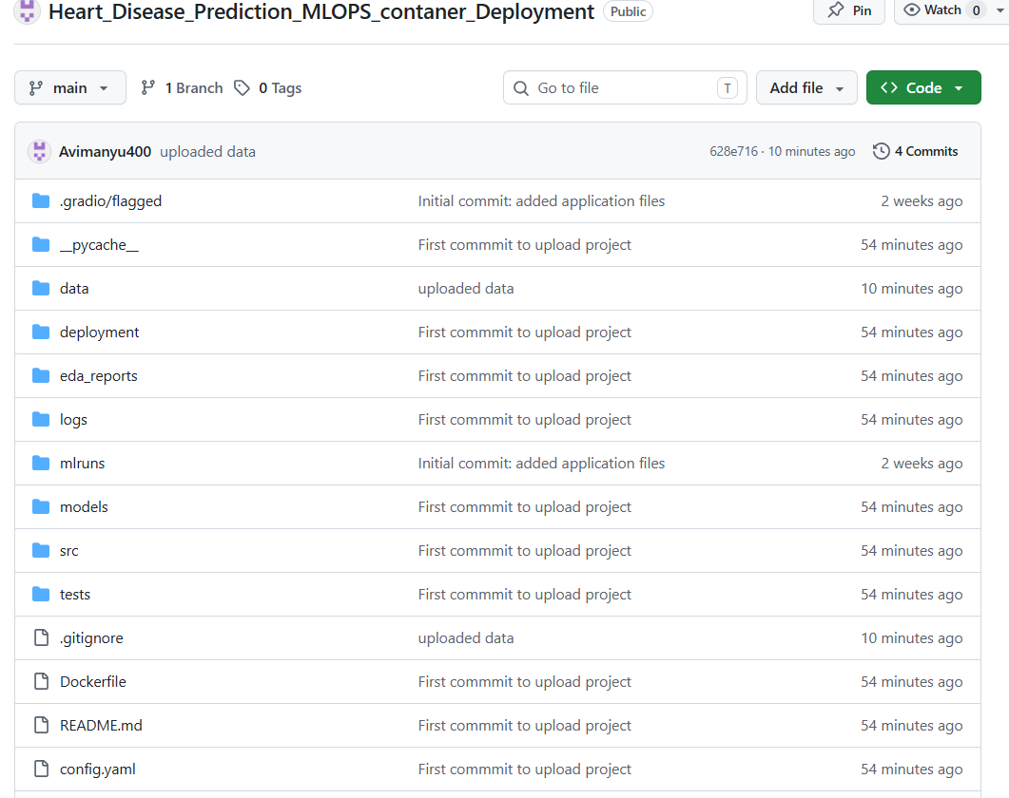

Upload new version of README.md file
D:\>cd Heart_Disease_prediction
D:\Heart_Disease_prediction>git status
On branch main
Your branch is up to date with 'origin/main'.

Changes not staged for commit:
(use "git add <file>..." to update what will be committed)
(use "git restore <file>..." to discard changes in working directory)
modified: README.md

Untracked files:
(use "git add <file>..." to include in what will be committed)
Git Setup.docx

no changes added to commit (use "git add" and/or "git commit -a")

D:\Heart_Disease_prediction>git add README.md
warning: in the working copy of 'README.md', LF will be replaced by CRLF the next time Git touches it

D:\Heart_Disease_prediction>git commit -m "Update README.md with new version"
[main da4a173] Update README.md with new version
1 file changed, 122 insertions(+), 90 deletions(-)

D:\Heart_Disease_prediction>git push origin main
Enumerating objects: 5, done.
Counting objects: 100% (5/5), done.
Delta compression using up to 12 threads
Compressing objects: 100% (3/3), done.
Writing objects: 100% (3/3), 2.35 KiB | 2.35 MiB/s, done.
Total 3 (delta 1), reused 0 (delta 0), pack-reused 0 (from 0)
remote: Resolving deltas: 100% (1/1), completed with 1 local object.
To https://github.com/Avimanyu400/Heart_Disease_Prediction_MLOPS_Container_Deployment.git
628e716..da4a173 main -> main

D:\Heart_Disease_prediction>
==============================================================\

